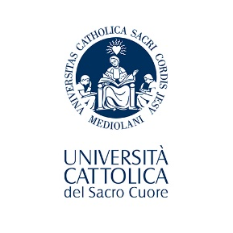 | Università Cattolica del Sacro Cuore  VSLO INTERNSHIP PROGRAM
A: PERSONAL INFORMATION

To be completed by student. Please print or type:

NAME
Last | First | Middle
Male [ ] Female [ ]
Date of Birth [MM/DD/YEAR]
Citizenship

Mailing Address

Street
City
State Zip
Country
Email address
Telephone Number

PLEASE COMPLETE SECTIONS B AND C, FOR EACH ELECTIVE YOU WOULD LIKE TO APPLY TO

B: DETAILS OF PROPOSED ELECTIVES)

Host Institution | Elective and/or Research requested: (i.e. General Medicine, Surgery, Paediatrics).

C: REQUEST FOR ACADEMIC RECOGNITION

Please provide details on learning objectives to be accomplished: clinical department, goals, tasks and workload to be performed, and planned period of the mobility.

(if necessary, please provide additional details on a separate sheet)
I attest that the information given in this application is accurate and true.

Student’s Signature: ________________________ Date: ________________________

D. ACADEMIC APPROVAL AND CREDIT RECOGNITION:

The above proposal is provisionally approved; upon the successful completion of the program, the applicant will be awarded _______ credits of clinical research elective.

___________________________ Date: ________________________
(Academic Adviser’s Signature)

